**Eclipse IDE Installation Guide**

This guide is to help you download the Eclipse IDE on a personal computer to run the Grease Webpage. If you would like, it is possible to install the Eclipse IDE on the Raspberry Pi but this will not be covered in this guide.

1. To begin the download process, go to the Eclipse website <https://www.eclipse.org/downloads/> and download the Eclipse installer.
2. For Windows users, after the Eclipse Installer executable has finished downloading it should be available in your download directory. Start the Eclipse Installer executable. You may get a security warning to run this file. If the Eclipse Foundation is the Publisher, you are good to select Run. For Mac and Linux users, you will still need to unzip the download to create the Installer. Start the Installer once it is available.

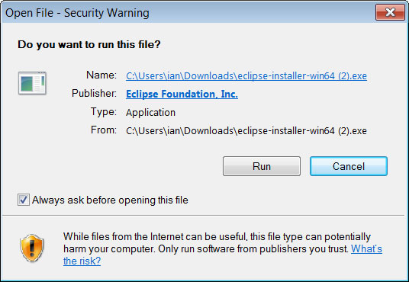

1. The Eclipse installer shows the packages available to Eclipse users. Search for the package, Eclipse IDE for Enterprise Java and Web Developers, select and click on the package to install.

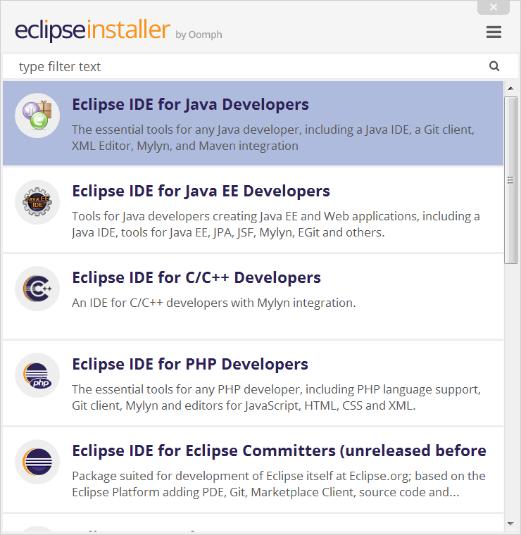

1. Specify the folder where you want Eclipse to be installed. The default folder will be in your User directory. Select the ‘Install’ button to begin the installation.
2. Once the installation is complete you can now launch Eclipse. The Eclipse Installer has done its work.